Handsworth Medical Practice
Opening times:

Handsworth Medical Practice
Telephone 0114 2697505
Reception = Option 1
Secretary/Admin/Referrals= Option 2
(Between 10am – 2pm)
Prescriptions (11am - 6pm)= Option 3

Monday - Friday 8:00am – 6:30pm

Fitzalan Site
Telephone 0114 2889777

Monday, Tuesday, Wednesday & Friday
8:00am - 6:30pm

Thursday 8:00am – 1:00pm

Please note our phone lines are closed between 12:00pm – 1:30pm

Newsletter

Patient Updates for 2025!

Prescriptions!
Prescription requests can be posted through the letterbox or passed to the receptionist at both surgeries. You can also order your prescription via our SystmOnline Service, NHS App, AccuRx (on our website). We cannot accept prescription requests via email or from pharmacies.

GP Registrars!

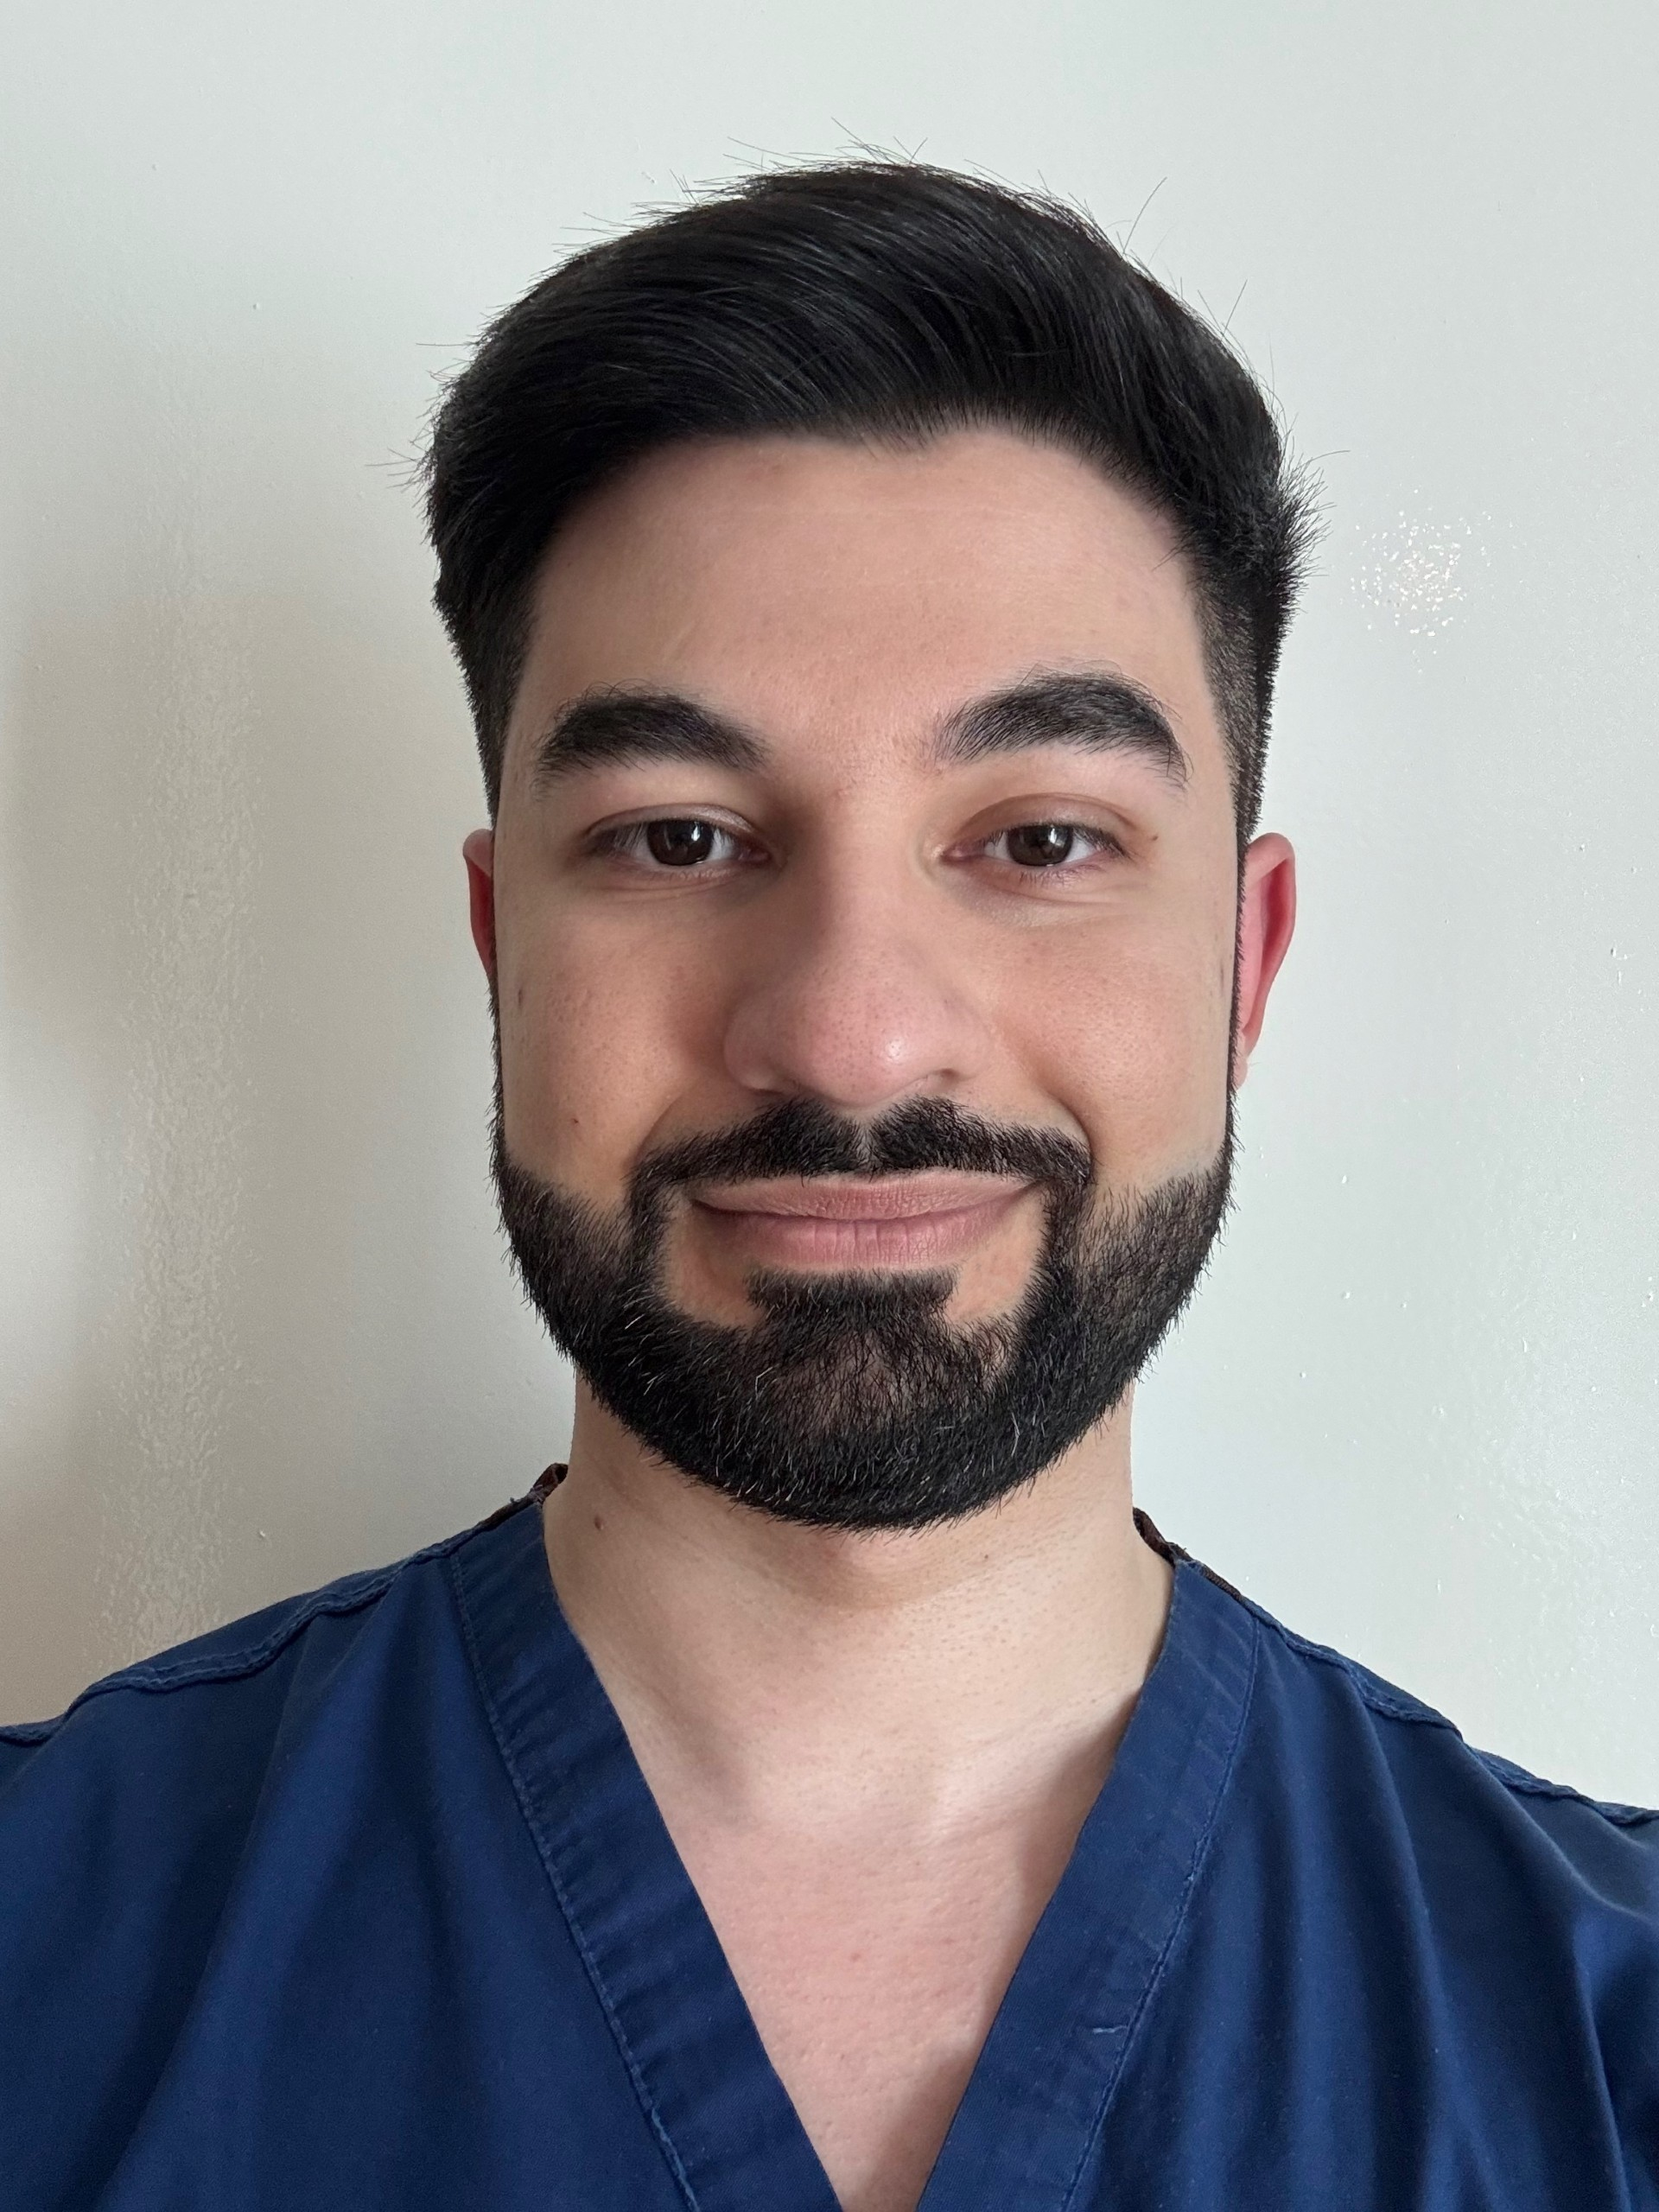
We have two new GP Registrars, who are working with us for 12 months.
Their names are Dr Chaudhry and Dr Alomaim


Bank Holidays!


The surgery will be closed on the following upcoming bank holidays:

- Friday 18th April
- Monday 21st April
- Monday 5th May
- Monday 26th May


Patient Participation Group!
We are looking for new members to join our PPG. We meet 1-2 times a year for patients to be able to bring forward suggestions & new ideas to help us improve the services that we offer. Please complete below and return to reception if you are interested.
Name:……………………………………………………….

Contact Number:…………………….……………….

To cancel any appointments please text your full name, date of birth and the date of your appointment to:

07904108206

Website Address:
www.handsworthmedicalpractice.co.uk

System Online Services:

Register at reception to enable you to request prescriptions, book & cancel appointments 24 hrs a day.

Community Activities around Handsworth!
These activities are either free or a small fee will be applicable, please contact the group if interested. Please contact the provider in case there are any changes

DAY | TIME | ACTIVITY | VENUE | CONTACT | NO.
MONDAY | 9:30AM  2 HRS | INTERNET DROP-IN | STRADBROOKE COMM CENTRE | CENTRE | 07583618617
MONDAY | 10:30AM  1.5 HRS | YOGA | SCOUT HALL, ST MARYS | JOYCE | 07498232169
MONDAY | 1:00PM  3 HRS | RICHMOND CINEMA | STRADBROOKE COMM CENTRE | SENIORS CLUB
MONDAY | 1:00PM  1 HR | GENTLE EXERCISE | SALVATION ARMY | BRYN COLLINSON
MONDAY | 1:30PM  1 HR | CHAIROBICS & GAMES | BRUNSWICK VILLAGE | STEFAN MURRAY
MONDAY | 1:30PM  1 HR | TAI CHI | WOODHOUSE LIBRARY | EXTERNAL COMP
MONDAY | 2:30PM  1 HR | CHAIROBICS & GAMES | RICHMOND TARA | NICOLA SWIFT
TUESDAY | 1:30PM  1 HR | HEALTH WALK | HANDSWORTH SCOUT HUT | TINA MOORES
TUESDAY | 2:00PM  2HRS | OVER 50’S SEQUENCE DANCING | THE RECTORY | TIM SCHAFER
TUESDAY | 5:30PM  1 HR | TAI CHI | WOODHOUSE LIBRARY | EXTERNAL COMP
WEDNESDAY | 9:30AM  2 HRS | INTERNET DROP-IN | STRADBROOKE COMM CENTRE | CENTRE | 07583618617
WEDNESDAY | 10:00AM  2 HRS | COMPUTER GROUP | WOODHOUSE LIBRARY
WEDNESDAY | 9:30AM  2 HRS | SEWING GROUP | RICHMOND TARA
WEDNESDAY | 10:30AM  1 HR | AMYS AUNTIES COFFEE MORNING | AMY’S HOUSE | MERIEL LITTLEWOOD | 0114 2697982
WEDNESDAY | 12:45PM  1 HR | MULTI EXERCISES | SALVATION ARMY | BRYN COLLINSON
WEDNESDAY | 2:00PM  2 HRS | OVER 50’S GROUP | RICHMOND TARA
WEDNESDAY | 2:00PM  2 HRS | HANDSWORTH ART SOCIETY | THE RECTORY | MEL | 0114 2697982
THURSDAY | 11:00AM  3 HRS | PENSIONERS LUNCH CLUB | THE RECTORY | TIM SCHAFER
THURSDAY | 1:00PM  2 HRS | CRAFT GROUP | THE NUNNERY (THE RECTORY)
THURSDAY | 1:30PM  1 HR | GENTLE EXERCISE | STRADBROOKE COMM CENTRE | AMY WHEELER
THURSDSAY | 1:30PM  2 HRS | CRAFT GROUP | WOODHOUSE LIBRARY | JACKIE | 07847602613
FRIDAY | 9:15AM  1 HR | COFFEE MORNING | SALVATION ARMY
FRIDAY | 10:00AM  2 HRS | COMPUTERS (LEARN MY WAY) | RICHMOND TARA
FRIDAY | 10:00AM  1 HR | KEEP FIT | SCOUT HALL, ST MARYS | MERIEL LITTLEWOOD
FRIDAY | 11:30AM  1 HR | CHAIR BASED EXERCISE | WOODHOUSE LIBRARY | WOODHOUSE FORUM | 0114 2690222
FRIDAY | 11:30AM  2 HRS | LUNCH DROP-IN | MTHODIST CHURCH, HANDSWORTH
FRIDAY | 1:30PM  1 HR | HEALTH WALK | WOODHOUSE LIBRARY | TINA MOORES
SATURDAY | 10:00AM  1 HR | KNIT & NATTER, CROCHET CHATTER | WOODHOUSE LIBRARY | SAM | 07891088479
Thursday | 1:30pm- 1.5 HRS | DEMENTIA CAFE | Handsworth Old Rectory Community Centre | JO-ANNE | 07495 548929

